**NAME:**SHRINIDHII MUTHUKUMARAN

**BATCH**:BATCH 8

**SQL CODING CHALLENGE**

**VIRTUAL ART GALLERY**

**Tables Creations:**

**1.Artists Table:**

CREATE TABLE Artists (

ArtistID INT PRIMARY KEY,

Name VARCHAR(255) NOT NULL,

Biography TEXT,

Nationality VARCHAR(100));

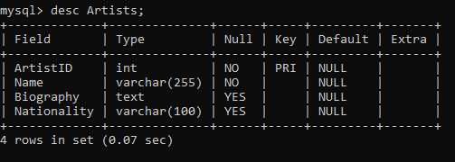

**2.Categories Table:**

CREATE TABLE Categories (

CategoryID INT PRIMARY KEY,

Name VARCHAR(100) NOT NULL);

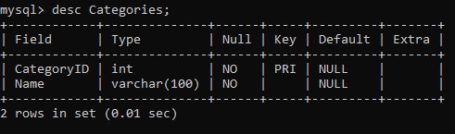

**3.Artworks Table:**

CREATE TABLE Artworks (

ArtworkID INT PRIMARY KEY,

Title VARCHAR(255) NOT NULL,

ArtistID INT,

CategoryID INT,

Year INT,

Description TEXT,

ImageURL VARCHAR(255),

FOREIGN KEY (ArtistID) REFERENCES Artists (ArtistID),

FOREIGN KEY (CategoryID) REFERENCES Categories (CategoryID));

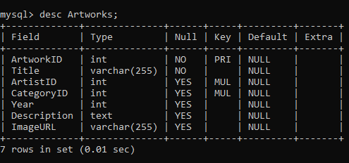

**4.Exhibitions Table:**

CREATE TABLE Exhibitions (

ExhibitionID INT PRIMARY KEY,

Title VARCHAR(255) NOT NULL,

StartDate DATE,

EndDate DATE,

Description TEXT);

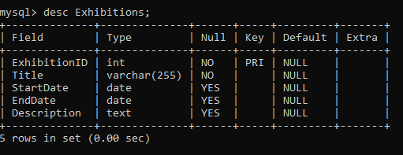

**5.ExhibitionArtworks Table**

CREATE TABLE ExhibitionArtworks (

ExhibitionID INT,

ArtworkID INT,

PRIMARY KEY (ExhibitionID, ArtworkID),

FOREIGN KEY (ExhibitionID) REFERENCES Exhibitions (ExhibitionID),

FOREIGN KEY (ArtworkID) REFERENCES Artworks (ArtworkID));  
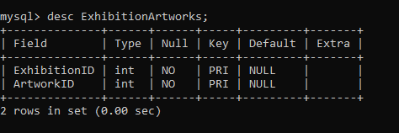

**ER Diagram:**

1. Artists & Artworks ==>One-to-Many
2. Categories & Artworks ==>One-to-Many
3. Exhibitions & ExhibitionArtworks ==>One-to-Many
4. Artworks & ExhibitionArtworks ==>One-to-Many

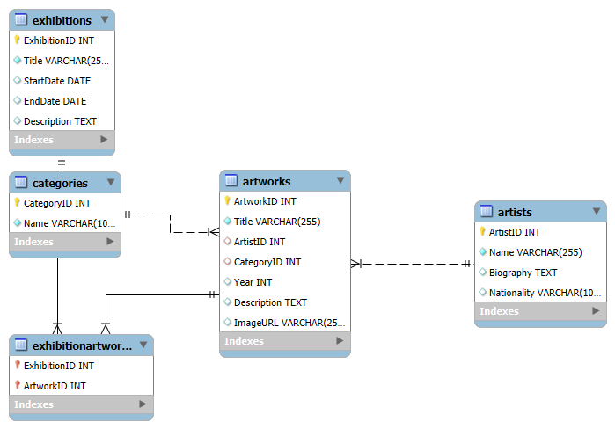

**Tables Values Insertion:**

**Artists:**

INSERT INTO Artists (ArtistID, Name, Biography, Nationality) VALUES

(1, 'Pablo Picasso', 'Renowned Spanish painter and sculptor.', 'Spanish'),

(2, 'Vincent van Gogh', 'Dutch post-impressionist painter.', 'Dutch'),

(3, 'Leonardo da Vinci', 'Italian polymath of the Renaissance.', 'Italian'),

(4, 'Claude Monet', 'French impressionist painter.', 'French'),

(5, 'Michelangelo', 'Italian sculptor, painter, and architect.', 'Italian'),

(6, 'Salvador Dalí', 'Spanish surrealist artist.', 'Spanish'),

(7, 'Frida Kahlo', 'Mexican painter known for self-portraits.', 'Mexican'),

(8, 'Andy Warhol', 'American pop art pioneer.', 'American'),

(9, 'Edvard Munch', 'Norwegian expressionist painter.', 'Norwegian'),

(10, 'Johannes Vermeer', 'Dutch Baroque painter.', 'Dutch');

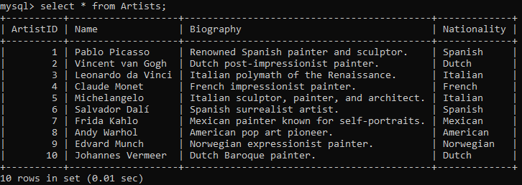

**Categories:**

INSERT INTO Categories (CategoryID, Name) VALUES

(1, 'Painting'),

(2, 'Sculpture'),

(3, 'Photography'),

(4, 'Impressionism'),

(5, 'Surrealism'),

(6, 'Abstract'),

(7, 'Pop Art'),

(8, 'Expressionism'),

(9, 'Baroque'),

(10, 'Realism');

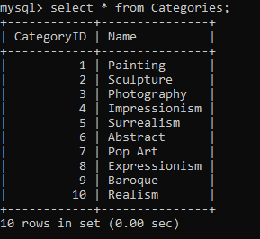

**Artworks:**

INSERT INTO Artworks (ArtworkID, Title, ArtistID, CategoryID, Year, Description, ImageURL) VALUES

(1, 'Starry Night', 2, 1, 1889, 'A famous painting by Vincent van Gogh.', 'starry_night.jpg'),

(2, 'Mona Lisa', 3, 1, 1503, 'The iconic portrait by Leonardo da Vinci.', 'mona_lisa.jpg'),

(3, 'Guernica', 1, 1, 1937, 'Pablo Picasso\'s powerful anti-war mural.', 'guernica.jpg'),

(4, 'Water Lilies', 4, 4, 1906, 'A series of paintings by Claude Monet.', 'water_lilies.jpg'),

(5, 'The Creation of Adam', 5, 1, 1512, 'A fresco painting by Michelangelo.', 'creation_of_adam.jpg'),

(6, 'The Persistence of Memory', 6, 5, 1931, 'Surrealist painting by Salvador Dalí.', 'persistence_of_memory.jpg'),

(7, 'The Two Fridas', 7, 1, 1939, 'A double self-portrait by Frida Kahlo.', 'two_fridas.jpg'),

(8, 'Marilyn Diptych', 8, 7, 1962, 'A pop art painting by Andy Warhol.', 'marilyn_diptych.jpg'),

(9, 'The Scream', 9, 8, 1893, 'An iconic expressionist painting by Edvard Munch.', 'the_scream.jpg'),

(10, 'Girl with a Pearl Earring', 10, 9, 1665, 'A famous Baroque portrait by Johannes Vermeer.', 'girl_with_pearl_earring.jpg');

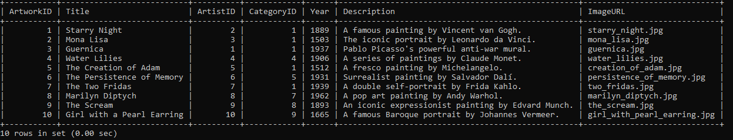

**Exhibitions :**

INSERT INTO Exhibitions (ExhibitionID, Title, StartDate, EndDate, Description) VALUES

(1, 'Modern Art Masterpieces', '2023-01-01', '2023-03-01', 'A collection of modern art masterpieces.'),

(2, 'Renaissance Art', '2023-04-01', '2023-06-01', 'A showcase of Renaissance art treasures.'),

(3, 'Impressionist Wonders', '2023-07-01', '2023-09-01', 'Exploring the wonders of Impressionism.'),

(4, 'Surrealism Unleashed', '2023-10-01', '2023-12-01', 'A journey into the surrealist movement.'),

(5, 'The Art of Pop Culture', '2024-01-01', '2024-03-01', 'Showcasing pop art and its cultural impact.'),

(6, 'Expressionist Visions', '2024-04-01', '2024-06-01', 'An exhibition on Expressionist masterpieces.'),

(7, 'Baroque and Beyond', '2024-07-01', '2024-09-01', 'A deep dive into the Baroque era and its influence.'),

(8, 'Realism Through Time', '2024-10-01', '2024-12-01', 'Showcasing realism in art across centuries.'),

(9, 'Masterpieces of the Ages', '2025-01-01', '2025-03-01', 'A grand exhibition of timeless artworks.'),

(10, 'The Genius of Michelangelo', '2025-04-01', '2025-06-01', 'Celebrating Michelangelo’s works.')

(11, 'The Weeping Woman', 1, 1, 1937, 'A famous painting by Pablo Picasso.', 'weeping_woman.jpg'),

(12, 'Les Demoiselles d\'Avignon', 1, 1, 1907, 'A revolutionary painting by Picasso.', 'demoiselles_avignon.jpg')

(13, 'Girl before a Mirror', 1, 1, 1932, 'A famous cubist painting by Pablo Picasso.', 'girl_before_mirror.jpg');

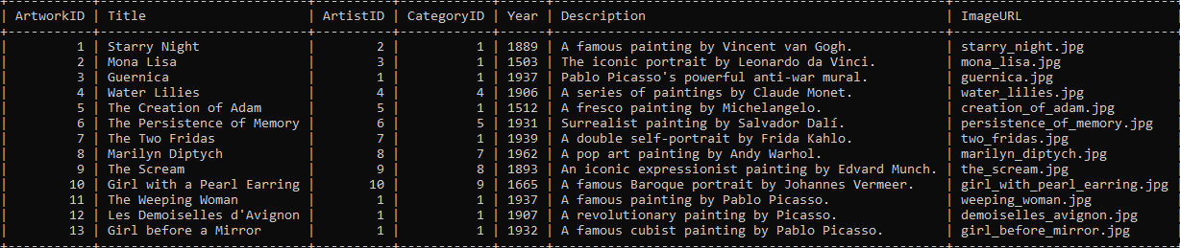

**ExhibitionArtworks:**

INSERT INTO ExhibitionArtworks (ExhibitionID, ArtworkID) VALUES

(1, 1),

(1, 2),

(1, 3),

(2, 2),

(3, 4),

(4, 6),

(5, 8),

(6, 9);

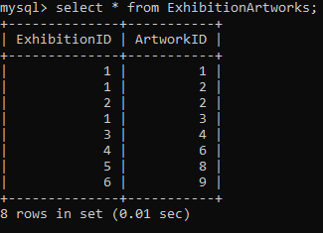

**Solve the below queries:**

1. **Retrieve the names of all artists along with the number of artworks they have in the gallery, and list them in descending order of the number of artworks.**

SELECT A.Name, COUNT(AR.ArtworkID) AS ArtworkCount

FROM Artists A

LEFT JOIN Artworks AR ON A.ArtistID = AR.ArtistID

GROUP BY A.ArtistID, A.Name

ORDER BY ArtworkCount DESC;

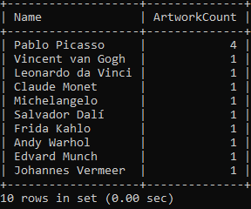

1. **List the titles of artworks created by artists from 'Spanish' and 'Dutch' nationalities, and order them by the year in ascending order.**

SELECT AR.Title, A.Name, A.Nationality, AR.Year

FROM Artworks AR

JOIN Artists A ON AR.ArtistID = A.ArtistID

WHERE A.Nationality IN ('Spanish', 'Dutch')

ORDER BY AR.Year ASC;

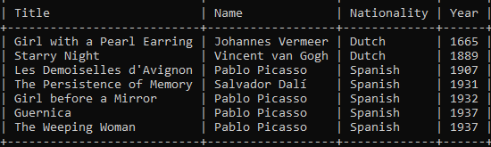

1. **Find the names of all artists who have artworks in the 'Painting' category, and the number of artworks they have in this category.**

SELECT A.Name, COUNT(AR.ArtworkID) AS PaintingCount

FROM Artists A

JOIN Artworks AR ON A.ArtistID = AR.ArtistID

JOIN Categories C ON AR.CategoryID = C.CategoryID

WHERE C.Name = 'Painting'

GROUP BY A.ArtistID, A.Name;

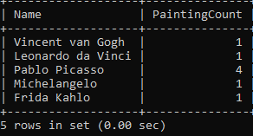

1. **List the names of artworks from the 'Modern Art Masterpieces' exhibition, along with their artists and categories.**

SELECT AR.Title, A.Name AS Artist, C.Name AS Category

FROM Artworks AR

JOIN ExhibitionArtworks EA ON AR.ArtworkID = EA.ArtworkID

JOIN Exhibitions E ON EA.ExhibitionID = E.ExhibitionID

JOIN Artists A ON AR.ArtistID = A.ArtistID

JOIN Categories C ON AR.CategoryID = C.CategoryID

WHERE E.Title = 'Modern Art Masterpieces';

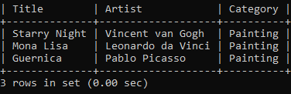

1. **Find the artists who have more than two artworks in the gallery.**

SELECT A.Name, COUNT(AR.ArtworkID) AS ArtworkCount

FROM Artists A

JOIN Artworks AR ON A.ArtistID = AR.ArtistID

GROUP BY A.ArtistID, A.Name

HAVING COUNT(AR.ArtworkID) > 2;

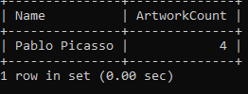

**6. Find the titles of artworks that were exhibited in both 'Modern Art Masterpieces' and 'Renaissance Art' exhibitions**

SELECT Artworks.Title

FROM Artworks

JOIN ExhibitionArtworks EA1 ON Artworks.ArtworkID = EA1.ArtworkID

JOIN Exhibitions E1 ON EA1.ExhibitionID = E1.ExhibitionID

JOIN ExhibitionArtworks EA2 ON Artworks.ArtworkID = EA2.ArtworkID

JOIN Exhibitions E2 ON EA2.ExhibitionID = E2.ExhibitionID

WHERE E1.Title = 'Modern Art Masterpieces'

AND E2.Title = 'Renaissance Art';



**7. Find the total number of artworks in each category**

SELECT c.Name, COUNT(aw.ArtworkID) AS TotalArtworks

FROM Categories c

LEFT JOIN Artworks aw ON c.CategoryID = aw.CategoryID

GROUP BY c.Name;

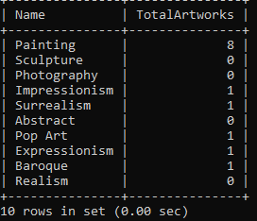

1. **List artists who have more than 3 artworks in the gallery.**

SELECT A.Name, COUNT(AR.ArtworkID) AS ArtworkCount

FROM Artists A

JOIN Artworks AR ON A.ArtistID = AR.ArtistID

GROUP BY A.ArtistID, A.Name

HAVING COUNT(AR.ArtworkID) > 3;



**9. Find the artworks created by artists from a specific nationality (e.g., Spanish).**

SELECT Artworks.Title, Artists.Name

FROM Artworks

JOIN Artists ON Artworks.ArtistID = Artists.ArtistID

WHERE Artists.Nationality = 'Spanish';

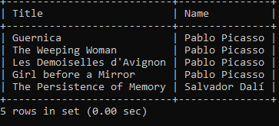

1. **Find all the artworks that have not been included in any exhibition.**

SELECT Title

FROM Artworks

WHERE ArtworkID NOT IN (SELECT ArtworkID FROM ExhibitionArtworks);

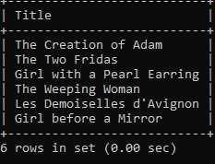

**13. List the total number of artworks in each category.**

SELECT c.Name, COUNT(aw.ArtworkID) AS TotalArtworks

FROM Categories c

LEFT JOIN Artworks aw ON c.CategoryID = aw.CategoryID

GROUP BY c.Name;

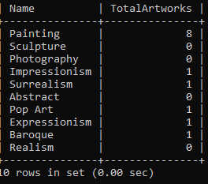

1. **Find the artists who have more than 2 artworks in the gallery.**

SELECT A.Name, COUNT(AR.ArtworkID) AS ArtworkCount

FROM Artists A

JOIN Artworks AR ON A.ArtistID = AR.ArtistID

GROUP BY A.ArtistID, A.Name

HAVING COUNT(AR.ArtworkID) > 2;

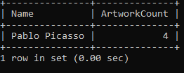

1. **List the categories with the average year of artworks they contain, only for categories with more than 1 artwork.**

SELECT Categories.Name, AVG(Artworks.Year) AS AvgYear

FROM Categories

JOIN Artworks ON Categories.CategoryID = Artworks.CategoryID

GROUP BY Categories.Name

HAVING COUNT(Artworks.ArtworkID) > 1;

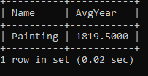

1. **Find the artworks that were exhibited in the 'Modern Art Masterpieces' exhibition.**

SELECT Artworks.Title

FROM Artworks

JOIN ExhibitionArtworks ON Artworks.ArtworkID = ExhibitionArtworks.ArtworkID

JOIN Exhibitions ON ExhibitionArtworks.ExhibitionID = Exhibitions.ExhibitionID

WHERE Exhibitions.Title = 'Modern Art Masterpieces';

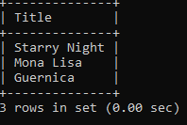

1. **Find the categories where the average year of artworks is greater than the average year of all artworks.**

SELECT Categories.Name

FROM Categories

JOIN Artworks ON Categories.CategoryID = Artworks.CategoryID

GROUP BY Categories.Name

HAVING AVG(Artworks.Year) > (SELECT AVG(Year) FROM Artworks);

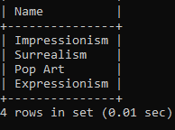

1. **List the artworks that were not exhibited in any exhibition.**

SELECT Title

FROM Artworks

WHERE ArtworkID NOT IN (SELECT ArtworkID FROM ExhibitionArtworks);

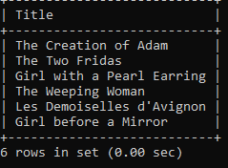

1. **Show artists who have artworks in the same category as "Mona Lisa."**

SELECT DISTINCT Artists.Name

FROM Artists

JOIN Artworks ON Artists.ArtistID = Artworks.ArtistID

WHERE Artworks.CategoryID = (SELECT CategoryID FROM Artworks WHERE Title = 'Mona Lisa');

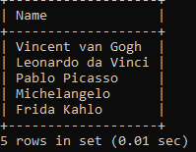

1. **List the names of artists and the number of artworks they have in the gallery**

SELECT A.Name, COUNT(AR.ArtworkID) AS ArtworkCount

FROM Artists A

LEFT JOIN Artworks AR ON A.ArtistID = AR.ArtistID

GROUP BY A.ArtistID, A.Name;

